Jenkins-02
- Configure 2 slave machines in the Jenkins master.
STEPS:
- Setup Jenkins Master
Run on MASTER EC2:
sudo dnf install java-17-amazon-corretto -y
sudo wget -O /etc/yum.repos.d/jenkins.repo https://pkg.jenkins.io/redhat-stable/jenkins.repo
sudo rpm --import https://pkg.jenkins.io/redhat-stable/jenkins.io-2023.key
sudo dnf install jenkins -y
sudo systemctl enable jenkins
sudo systemctl start jenkins
Open:
http://<MASTER-IP>:8080
- Prepare Slave Machines (BOTH)
Run on Slave 1 & Slave 2
sudo dnf install java-17-amazon-corretto -y
Verify:
java -version
No Jenkins install needed
- Setup SSH (CRITICAL STEP)
On MASTER
ssh-keygen
Press Enter 3 times
Copy public key
cat ~/.ssh/id_rsa.pub
Copy full key On SLAVE 1
mkdir -p ~/.ssh
nano ~/.ssh/authorized_keys
Paste key → Save
chmod 700 ~/.ssh
chmod 600 ~/.ssh/authorized_keys
Repeat for SLAVE 2
TEST (from MASTER only)
ssh ec2-user@172.31.39.152
ssh ec2-user@172.31.39.136
Must login without password
- Add Credentials in Jenkins
Go: Manage Jenkins → Credentials → Global → Add Credentials
Fill: Kind: SSH Username with private key
Username: ec2-user
Private Key: Enter directly
Paste: cat ~/.ssh/id_rsa
ID: ec2-key
Click Add
- Add Slave 1 Node
Go: Manage Jenkins → Nodes → New Node
Fill: Name: slave-1
Type: Permanent Agent
Configuration
Remote root: /home/ec2-user
Label: slave1
Usage: Use this node as much as possible
Launch method: Launch agents via SSH
Host: 172.31.18.55
Credentials:
ec2-key
Host Key Verification:
Non verifying
Save
Launch Agent
Click:
slave-1 → Launch agent
Status: Online
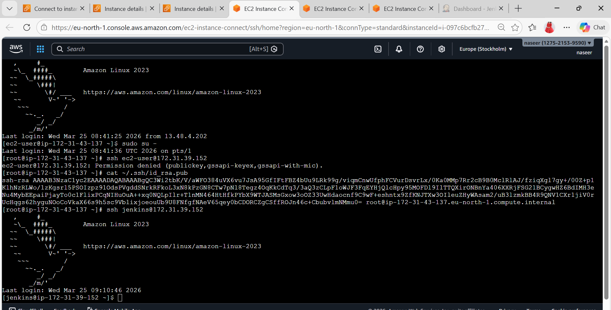

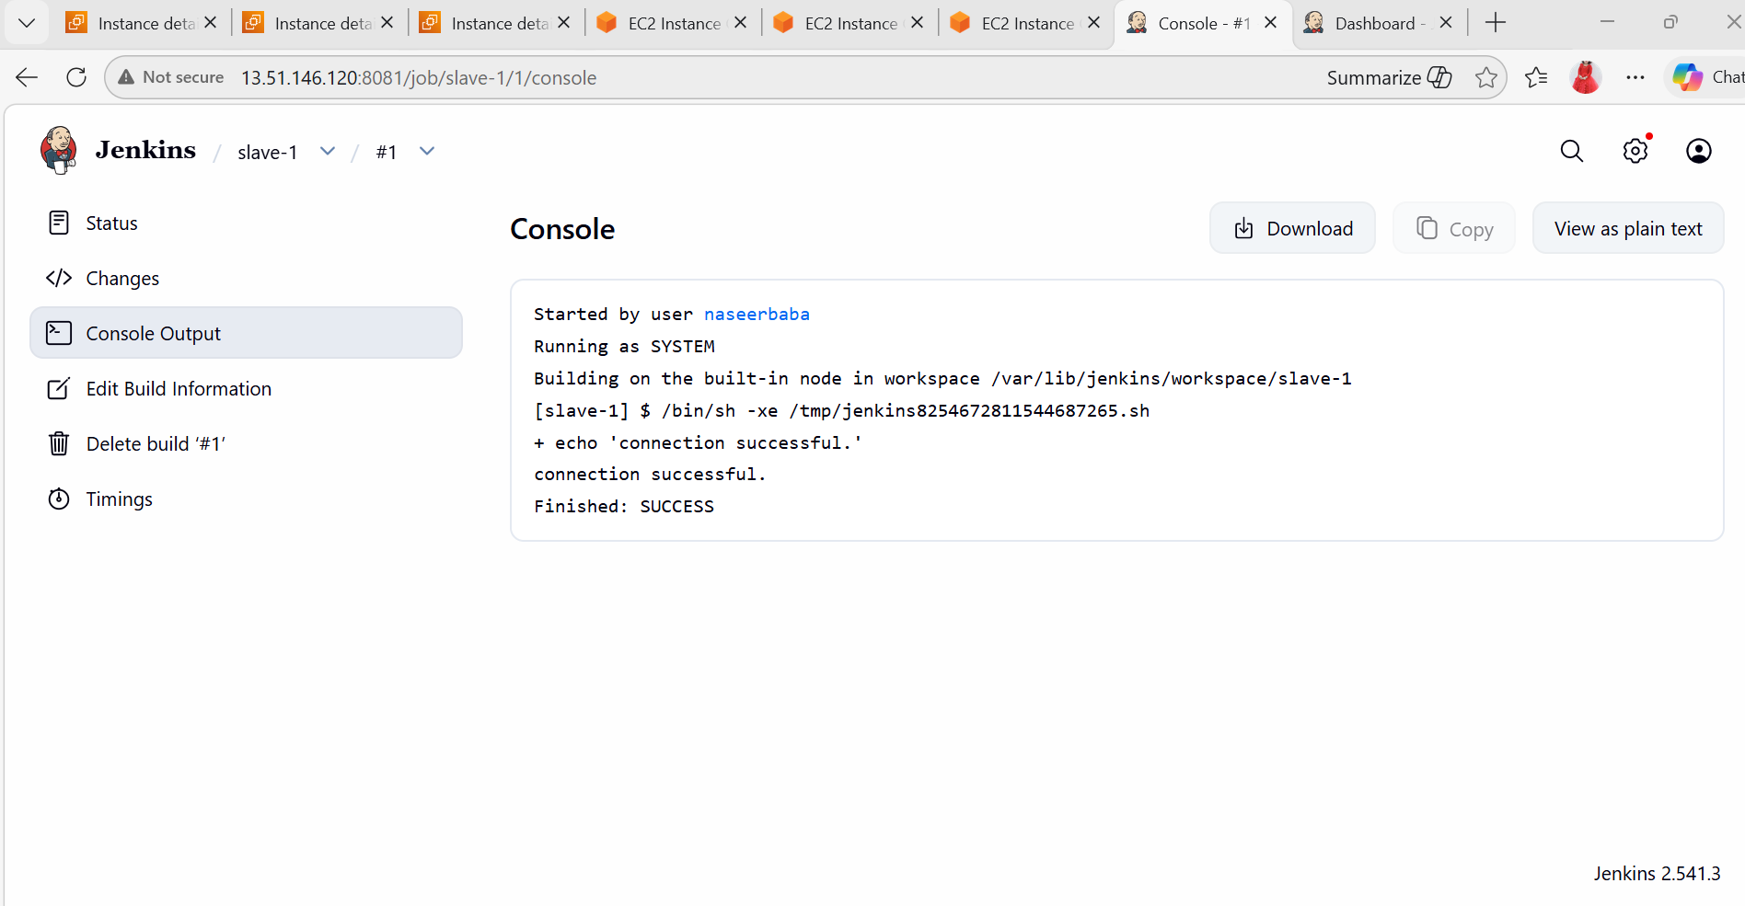
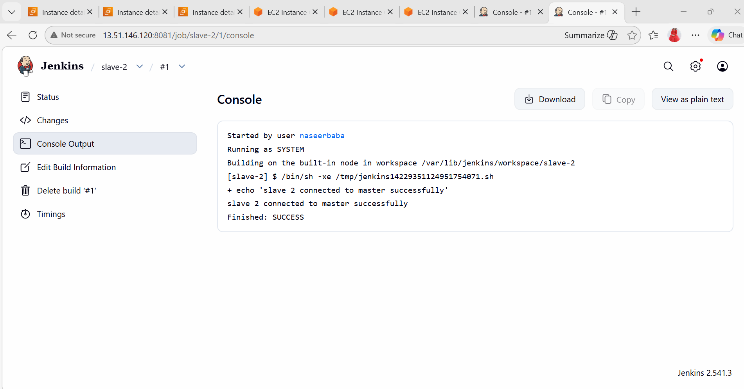
2. Configure webhooks to the Jenkins job.
GitHub → Repo → Settings → Webhooks
Payload URL:
http://<EC2-IP>:8080/github-webhook/
Content type: application/json
Event: Push
In Jenkins:
GitHub hook trigger for GITScm polling

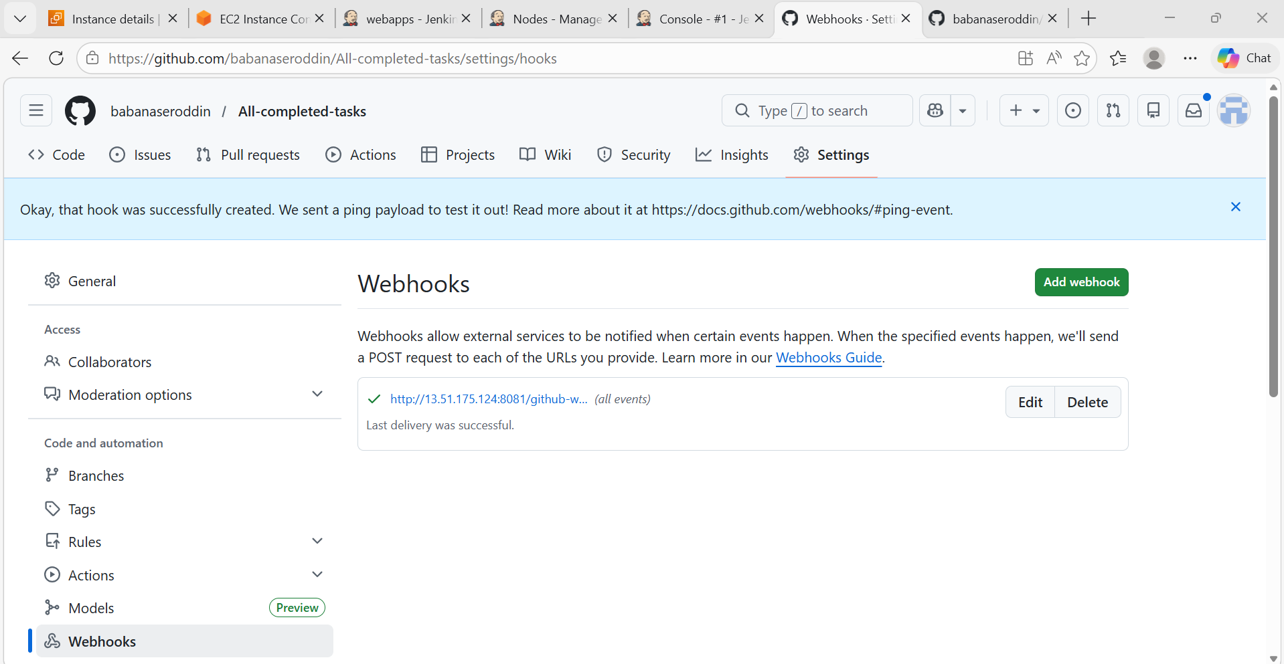
3. Configure Poll SCM and Build Periodically options in the Jenkins job.
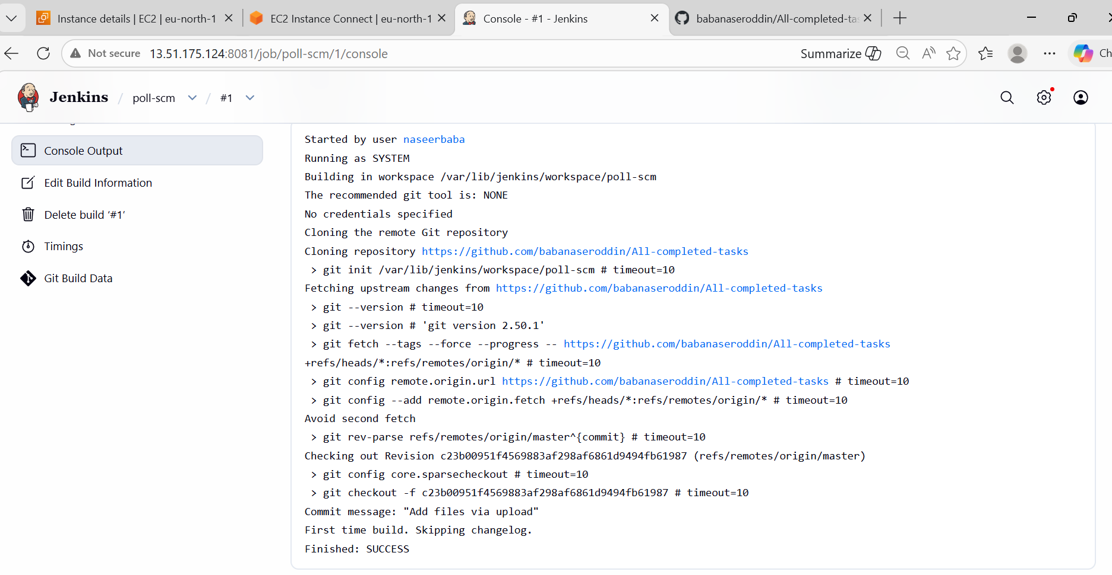
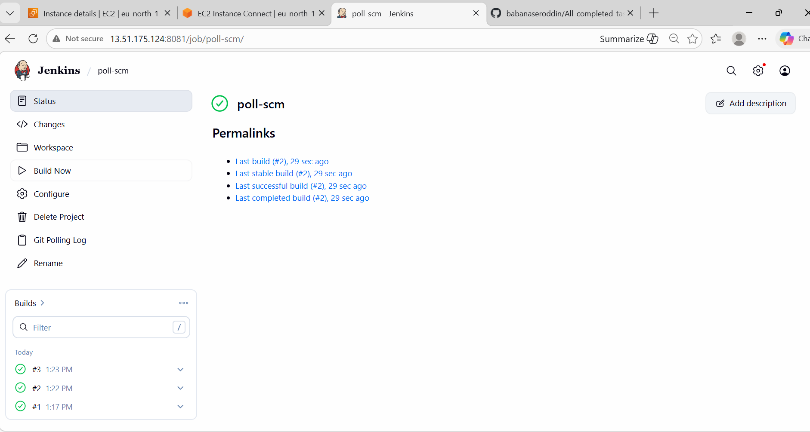

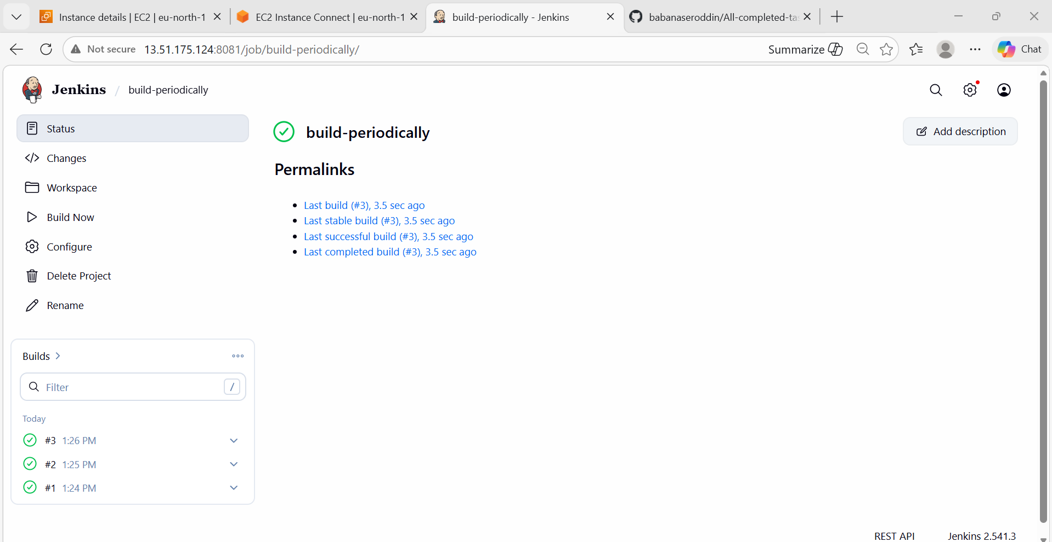
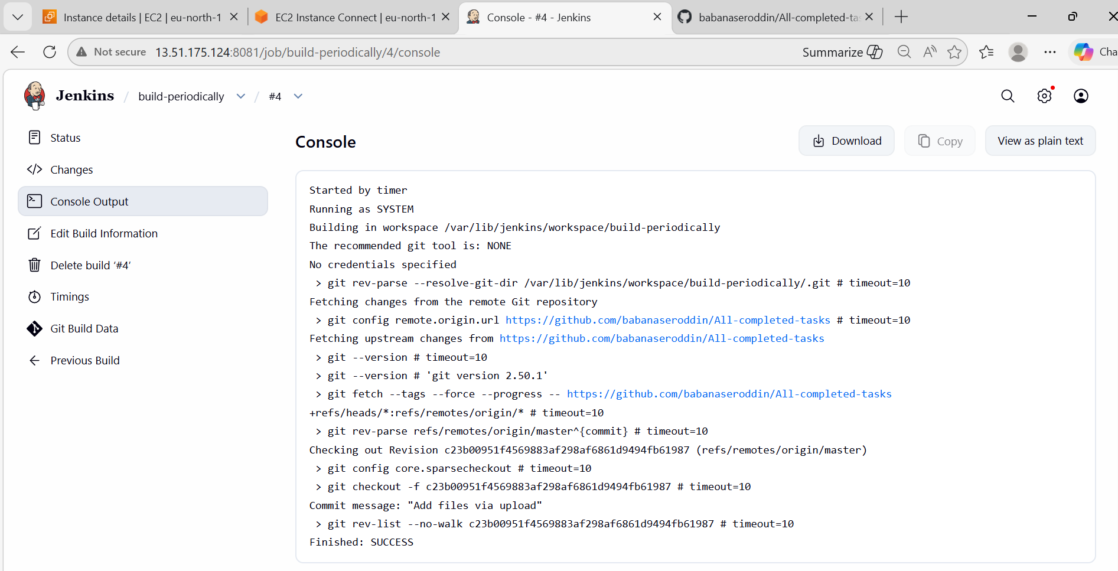
4. Take a backup of the Jenkins server using a bash-script.
Steps:
- Create Backup Folder with Proper Permission
sudo mkdir -p /opt/jenkins-backup
sudo chown -R ec2-user:ec2-user /opt/jenkins-backup
- Run Script with sudo (IMPORTANT)
Instead of: ./jenkins_backup.sh
Run: sudo ./jenkins_backup.sh
Better Script (Fix Permissions Properly)
Update your script like this
#!/bin/bash
JENKINS_HOME="/var/lib/jenkins"
BACKUP_DIR="/opt/jenkins-backup"
DATE=$(date +%F-%H-%M)
# Create backup directory
sudo mkdir -p $BACKUP_DIR
echo "Stopping Jenkins..."
sudo systemctl stop jenkins
echo "Taking backup..."
sudo tar -czvf $BACKUP_DIR/jenkins-backup-$DATE.tar.gz $JENKINS_HOME
echo "Starting Jenkins..."
sudo systemctl start jenkins
echo "Backup completed successfully!"
- Run Again
sudo ./jenkins_backup.sh
Expected Output
No errors
You’ll get:
/opt/jenkins-backup/jenkins-backup-2026-03-24-XX-XX.tar.gz

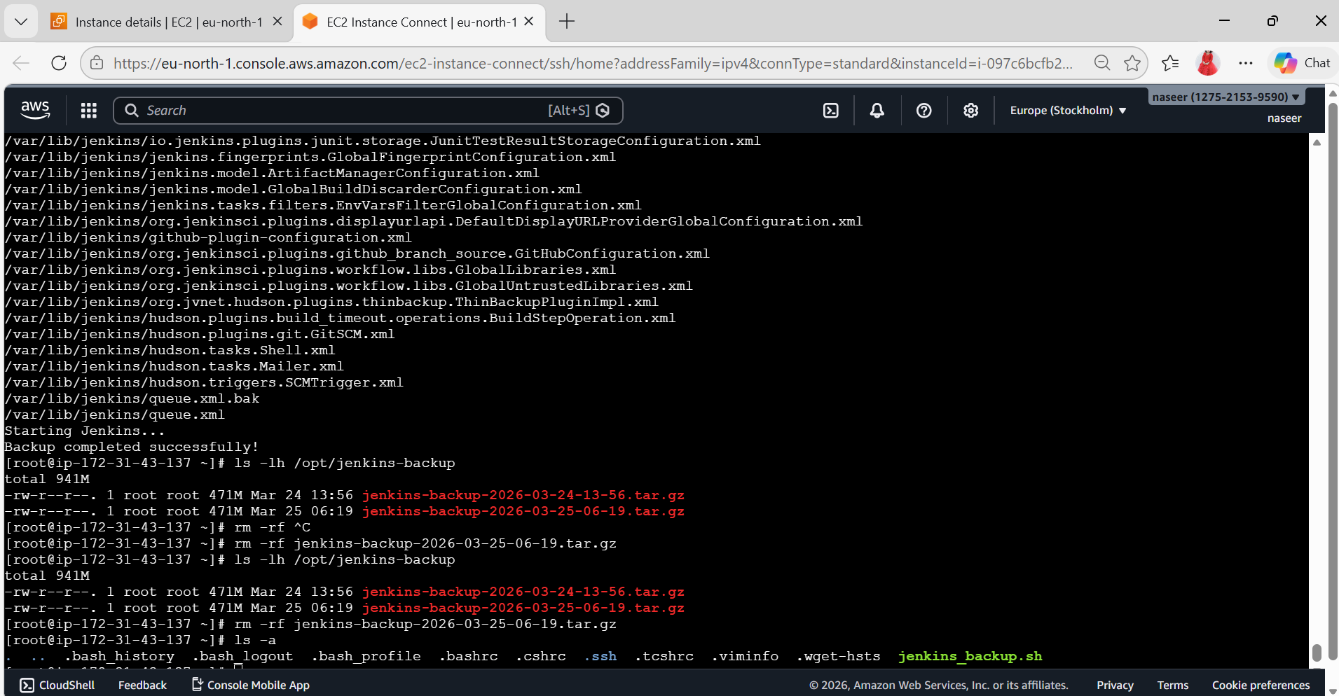
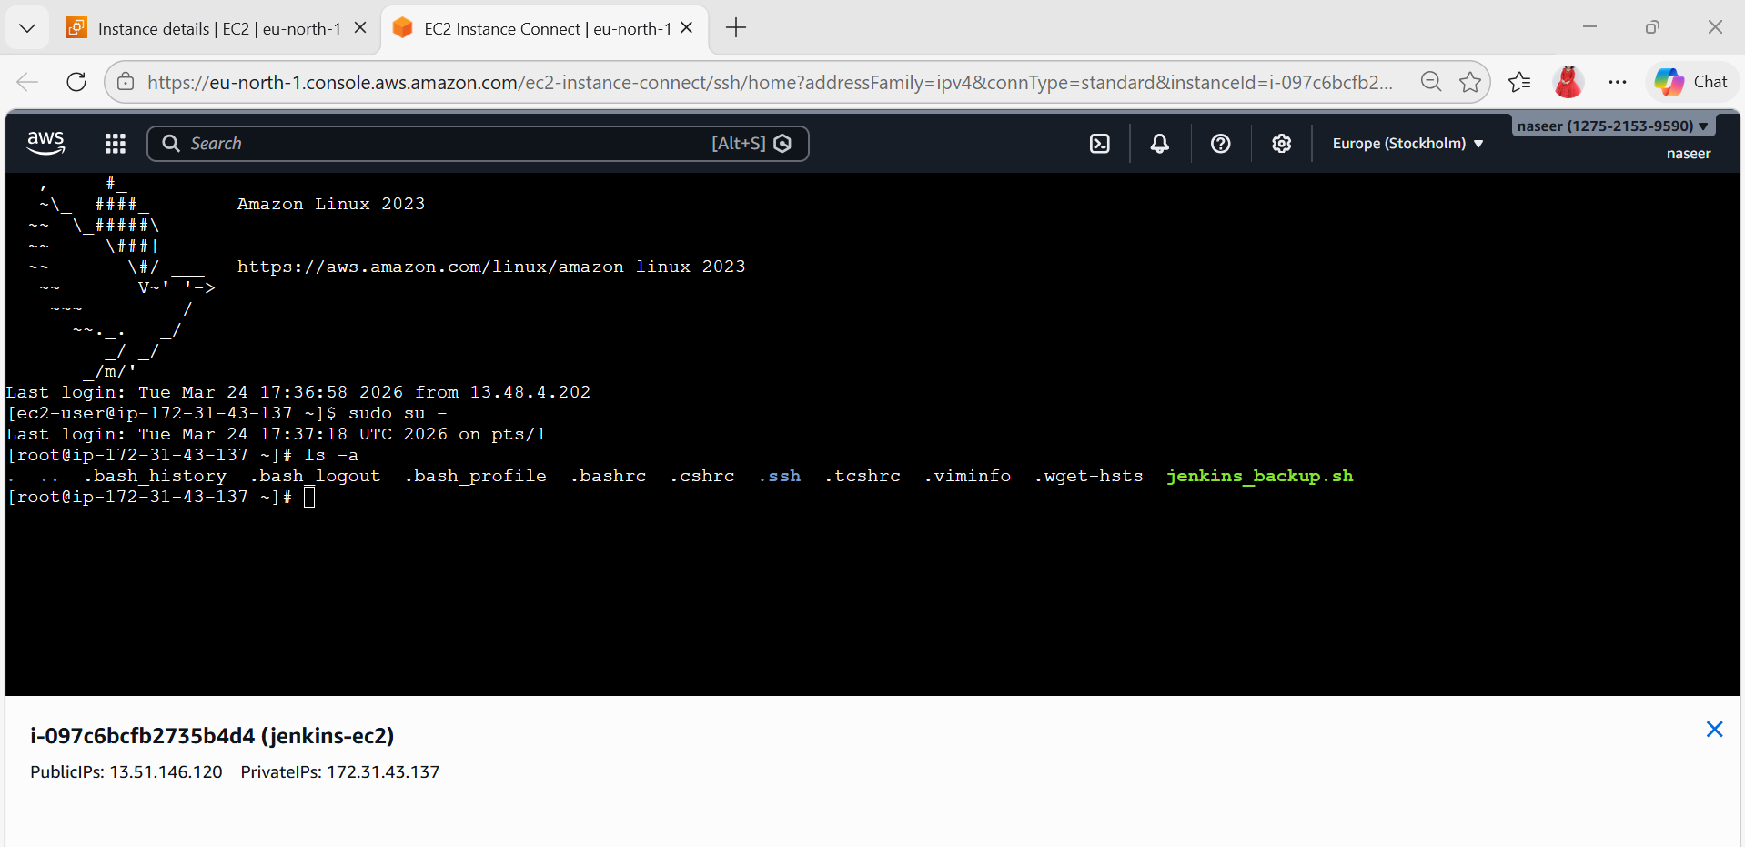

- Take a backup of Jenkins using the ThinBackup plugin.

Steps:
- Create Backup Folder (IMPORTANT)
Run this on your server:
sudo mkdir -p /var/lib/jenkins/backup
sudo chown -R jenkins:jenkins /var/lib/jenkins/backup
sudo chmod 755 /var/lib/jenkins/backup
- Save Configuration
Now go back to Jenkins UI:
Click Save
- Take Backup
Go to: Manage Jenkins → ThinBackupClick: Backup Now
- Verify Backup
Run:
ls -l /var/lib/jenkins/backup
You should see something like:
FULL-2026-03-24_XX-XX

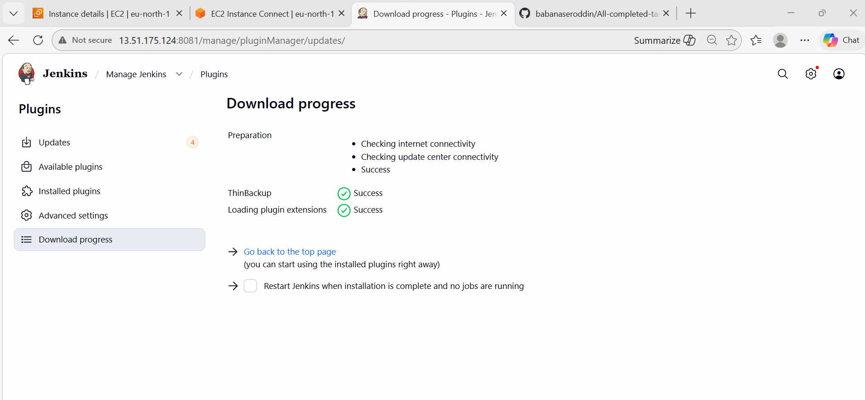

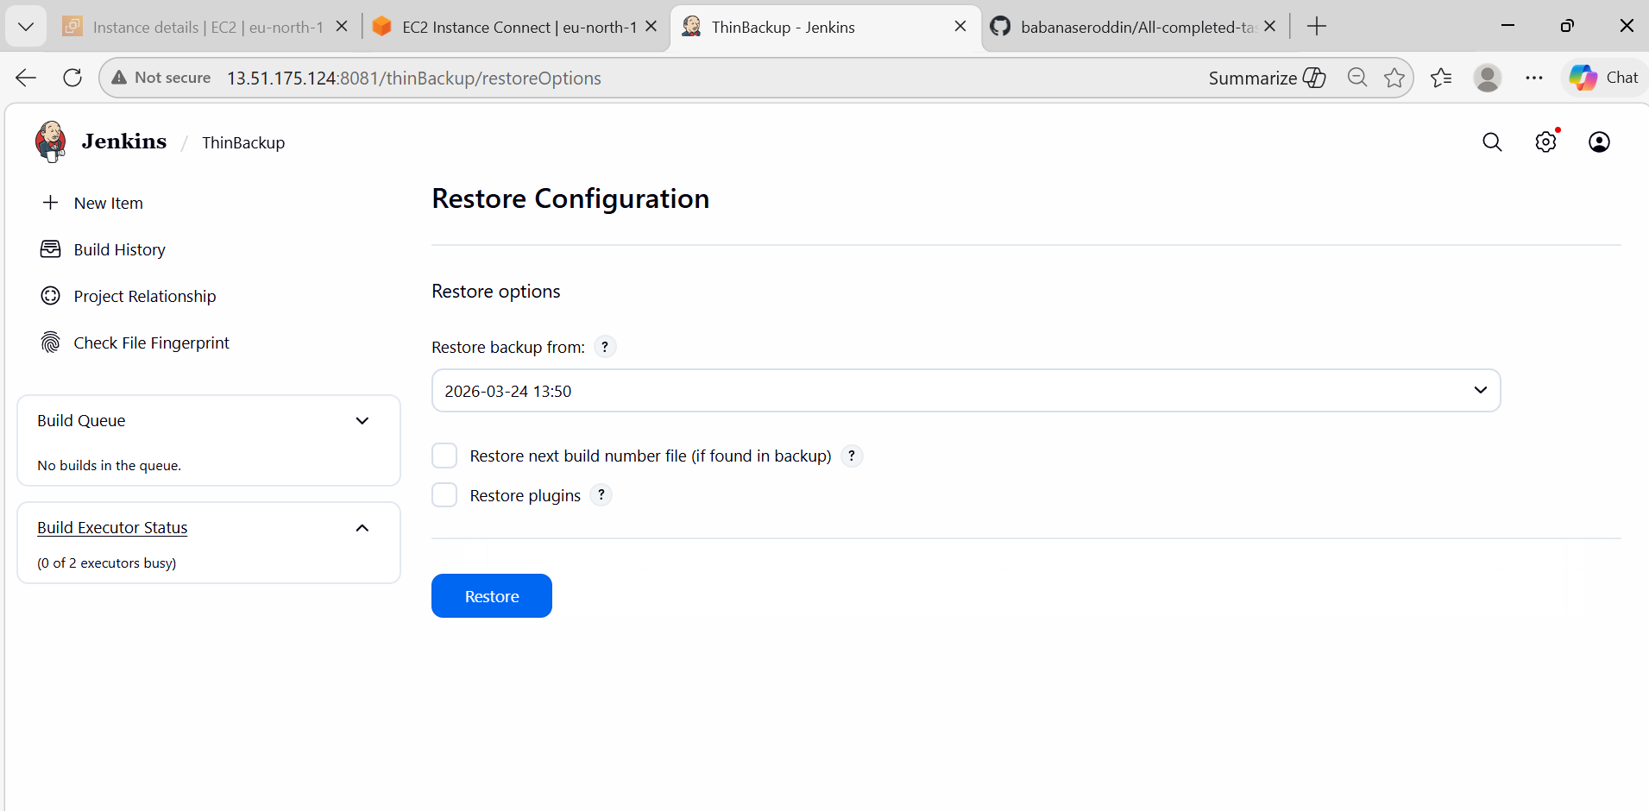
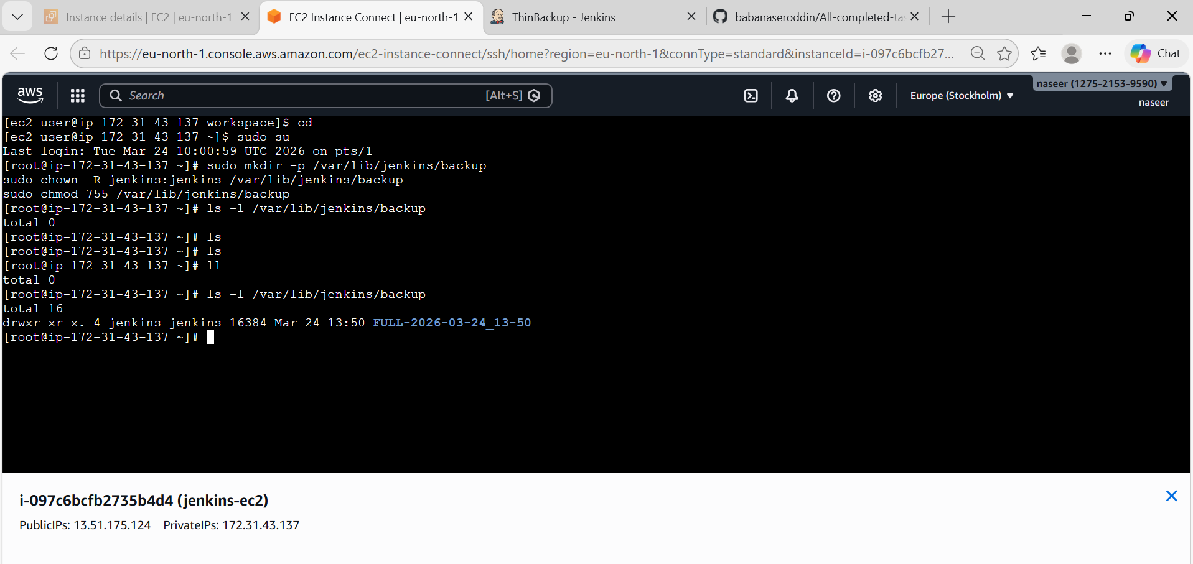
- Set up a new Jenkins server and restore the backup taken in task 4.
Restore Jenkins Backup on New Server
STEPS:
- Launch New Server
Create new VM (AWS EC2 / local / VM)
Minimum:
OS: Amazon Linux / Ubuntu
RAM: 2GB+
Open ports: 8080 (Jenkins)
- Install Java (Jenkins dependency)
For Amazon Linux:
sudo dnf install java-17-amazon-corretto -y
Check: java -version
- Install Jenkins
Amazon Linux:
sudo wget -O /etc/yum.repos.d/jenkins.repo https://pkg.jenkins.io/redhat-stable/jenkins.rep
sudo rpm --import https://pkg.jenkins.io/redhat-stable/jenkins.io-2023.key
sudo dnf install jenkins -y
- Start Jenkins
sudo systemctl daemon-reexec
sudo systemctl enable jenkins
sudo systemctl start jenkins
sudo systemctl status Jenkins
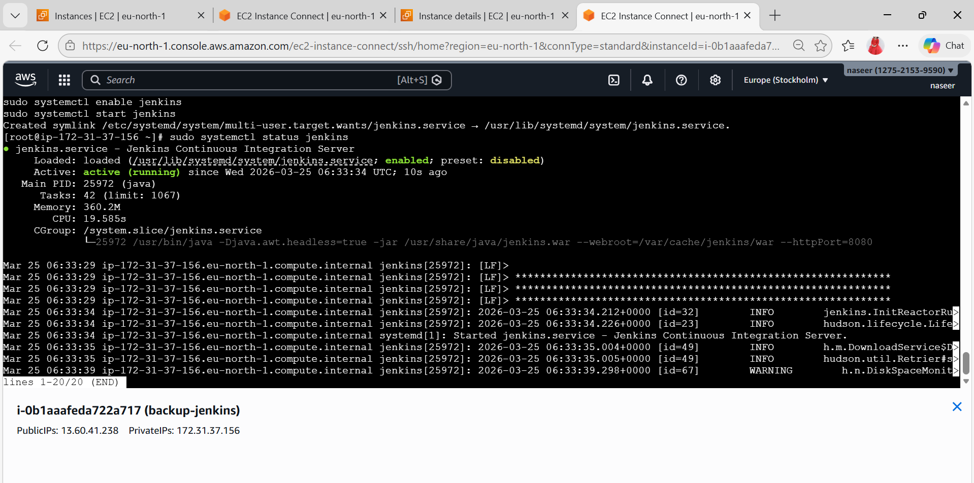
- Unlock Jenkins (First Time)
sudo cat /var/lib/jenkins/secrets/initialAdminPassword
Open browser:
http://<your-server-ip>:8080
- Start SSH Agent
eval $(ssh-agent)
- Add your key
ssh-add jenkins.pem
Expected output:
Identity added: jenkins.pem
- Now connect WITH agent forwarding
ssh -A ec2-user@13.60.41.238
If still fails (backup safe command)
Use both agent + key:
ssh -A -i jenkins.pem ec2-user@13.60.41.238
This ALWAYS works
After login (inside OLD EC2)
Run:
scp /opt/jenkins-backup/jenkins-backup-2026-03-25-06-20.tar.gz ec2-user@18.208.131.63:/home/ec2-user/
IMPORTANT CHECK (don’t skip)
Make sure NEW EC2 allows OLD EC2:
Security Group of NEW EC2:
SSH (22)
Source: 13.60.41.238/32

